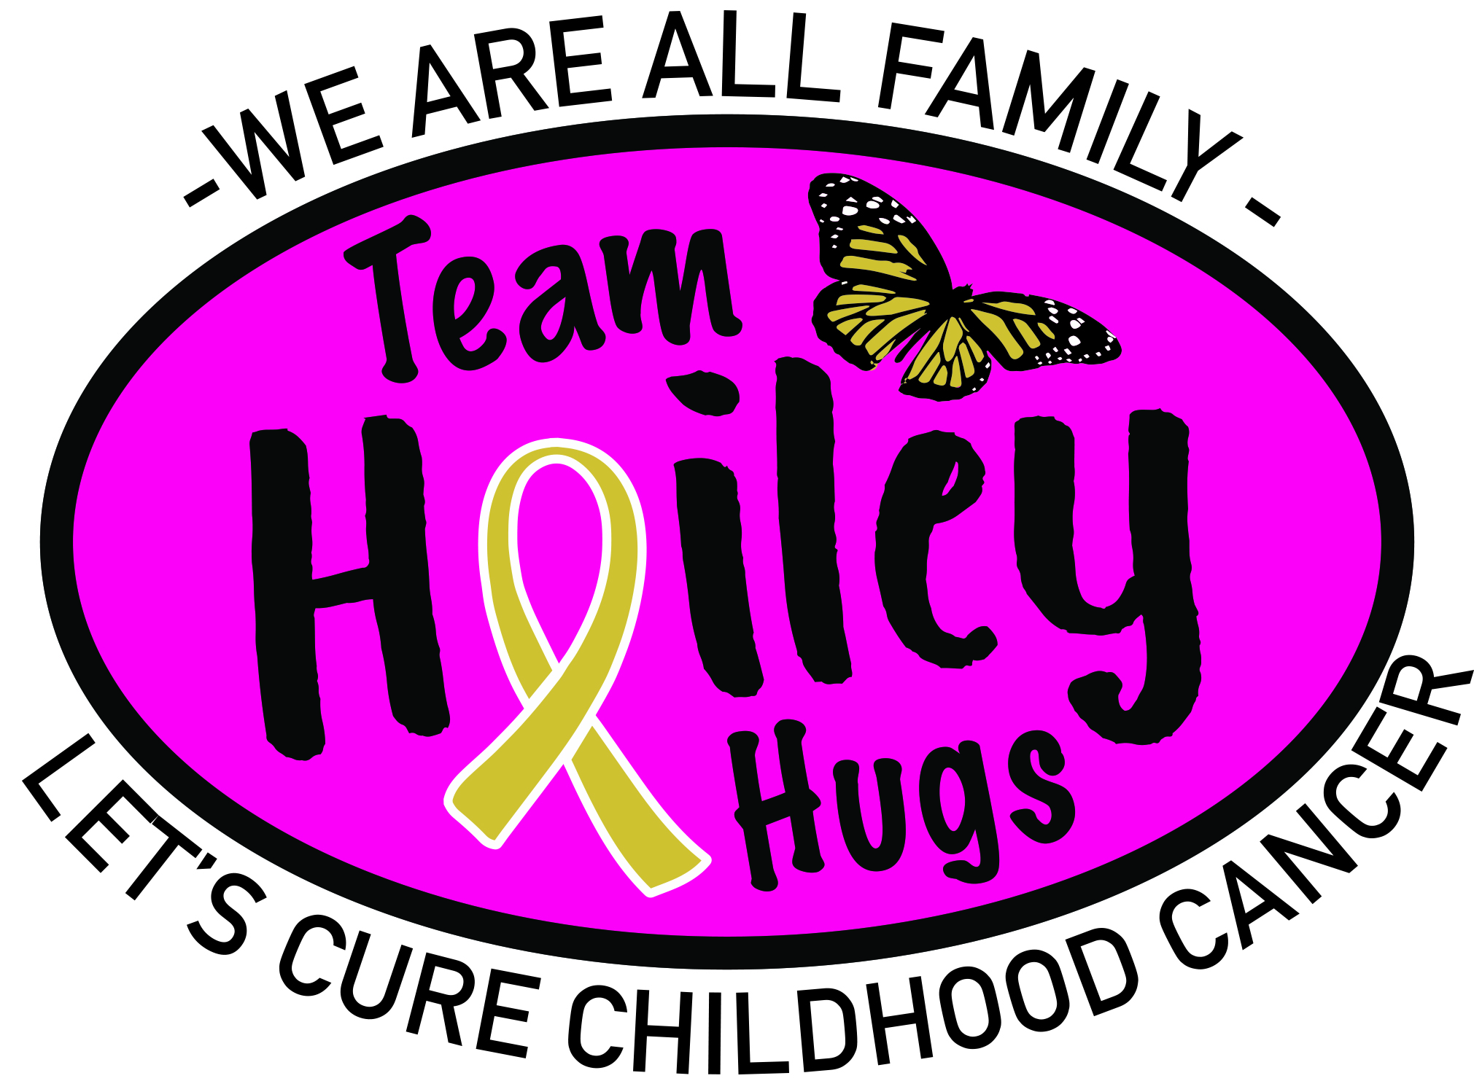

Proclamation

The State of Maine is Going Gold in the month of September from this year forth in support of Childhood Cancer Awareness.

Whereas, Cancer is the leading cause of death by disease among U.S. Children and is detected in more than 15,000 of our country's sons and daughters every year; and

Whereas, In the State of Maine cancer affects more than 50 new children and families annually, where more than 400 children are undergoing treatment currently and where we are ranked in the top range of incidence of all cancers at 468.3 per 100,00 people; and

Whereas, September is nationally recognized as Childhood Cancer Awareness Month; and

Whereas, thanks to ongoing advances in research and treatment, the five year survival rate for all childhood cancers has climbed from less than 50 percent to 80 percent over the last several decades; and

Whereas, innovative studies are leading to real breakthroughs reminding us of the importance of supporting scientific discovery and moving closer to finding cures, though much work remains to be done; and

Whereas, 1in 5 children diagnosed will not survive.

During National Childhood Cancer Awareness Month we remember the many children who have been taken from us too soon and we extend our support to all those who continue to battle this illness with incredible strength and courage.

Now, therefore, As of Town/City of , I, , proclaim that the Town/City of will help Maine Go Gold in support of Team Hailey Hugs and all of the children and families affected by Childhood Cancer. In doing so, from this day forward, we will recognize September as Maine Childhood Cancer Awareness Month. This is our way of paying tribute to the families, friends, professionals and communities who lend their strength to children fighting pediatric cancer.

Dated this ____ day of ____________, 2018

Printed

Signed

